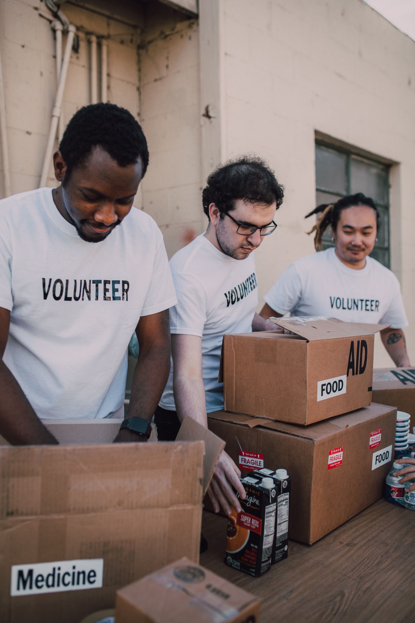NGO

WEBSITE

**PROJECT:** NGO WEBSITE

**Group Member:-**

|  |  |
| --- | --- |
| **GROUP MEMBER** | **ENROLMENT NO.** |
| Muhammad Affan Ansari  Urooj  Wania Aamir | Student1284822  Student1320044  Student1320352 |

**FACULTY :** AATIKA LIAQUAT

**BATCH CODE :** 2106B1

**CURRICULUM :** 6740

**SEMESTER :** DSIM



**Table of Contents: -**

1. Acknowledgment....................................................................................................... 4
2. Declaration…………………………………………………………………………………………………………… 4
3. Certificate…………………………………………………………………………………………………………….. 6
4. **CHAPTER 1 :** INTRODUCTION…………………………………………………………………………………. 7
5. Problem Statement………………………………………………………………………………… 7

* Functional Requirements……………………………………………………………. 8

1. Need of Project……………………………………………………………………………………… 16
2. **CHAPTER 2** : PROJECT MAKING & BACKGROUNDS………………………………………………. 17
3. Project Duration………………………………………………………………………………………. 18
4. Task Sheet……………………………………………………………………………………………….. 19
5. **CHAPTER 3** : SOFTWARE & HARDWARE REQUIREMENTS…………………………………… 20
6. Hardware Requirements……………………………………………………………………………. 21
7. Software Requirements……………………………………………………………………………… 21
8. **CHAPTER 4** : WORKFLOW SUBMISSION CHECKLIST…………………………………………..… 22
9. Workflow Submission Checklist……………………………………………………………………... 23
10. **CHAPTER 5** : Screenshots……………………………………………………………………………………… 25
11. **CHAPTER V**: CONCLUSION………………………………………………………………………………….. 30
12. Remarks………………………………………………………………………………………………………… 33
13. Problem Faced……………………………………………………………………………………………… 33
14. Future Enhancement……………………………………………………………………………………… 33

1- Acknowledgement:

We would want to appreciate and thank all of those people who helped us during this journey of completing our project. Without everyone’s support, we could not have accomplished our work.

We express our sincere gratitude to our faculty “--Miss Aatika Liaquat--" and our coordinator for their amazing support and guidance, continuous encouragement and supervision throughout the course of the present work. It’s of no doubt that we have been very fortunate to work under such a supportive and cooperative teacher/coordinator

And last but not the least we are extremely grateful to the whole faculty and administration of Aptech, for providing us all the facilities that were mandatory, without which this project could not be a success.

2- Declaration

We are writing this to declare that all the work which is being written bellow in this Project Report entitled “----**NGO WEBSITE----**” is a veritable record of our own work submitted to the Aptech NN, Karachi, Pakistan during the year 2020 to 2021 in the partial fulfillment of semester III (HDSE I) project We also declare that we have not submitted the material being presented in this Project Report for the award of any other degree elsewhere.

Signatures:

MUHAMMAD AFFAN ANSARI STUDENT1284822

UROOJ STUDENT1320044

WANIA AAMIR STUDENT1320352

Certificate: -

This is to certify that,

**Muhammad Affan Ansari**

**Urooj**

**Wania Aamir**

Has successfully Designed & Developed

**“ NGO WEBSITE ”**

Date of Issue:

**29-SEP-2022**

Date of Submission:

**29-OCT-2022**

Authorized Signature: **Miss Aatika Liaquat**

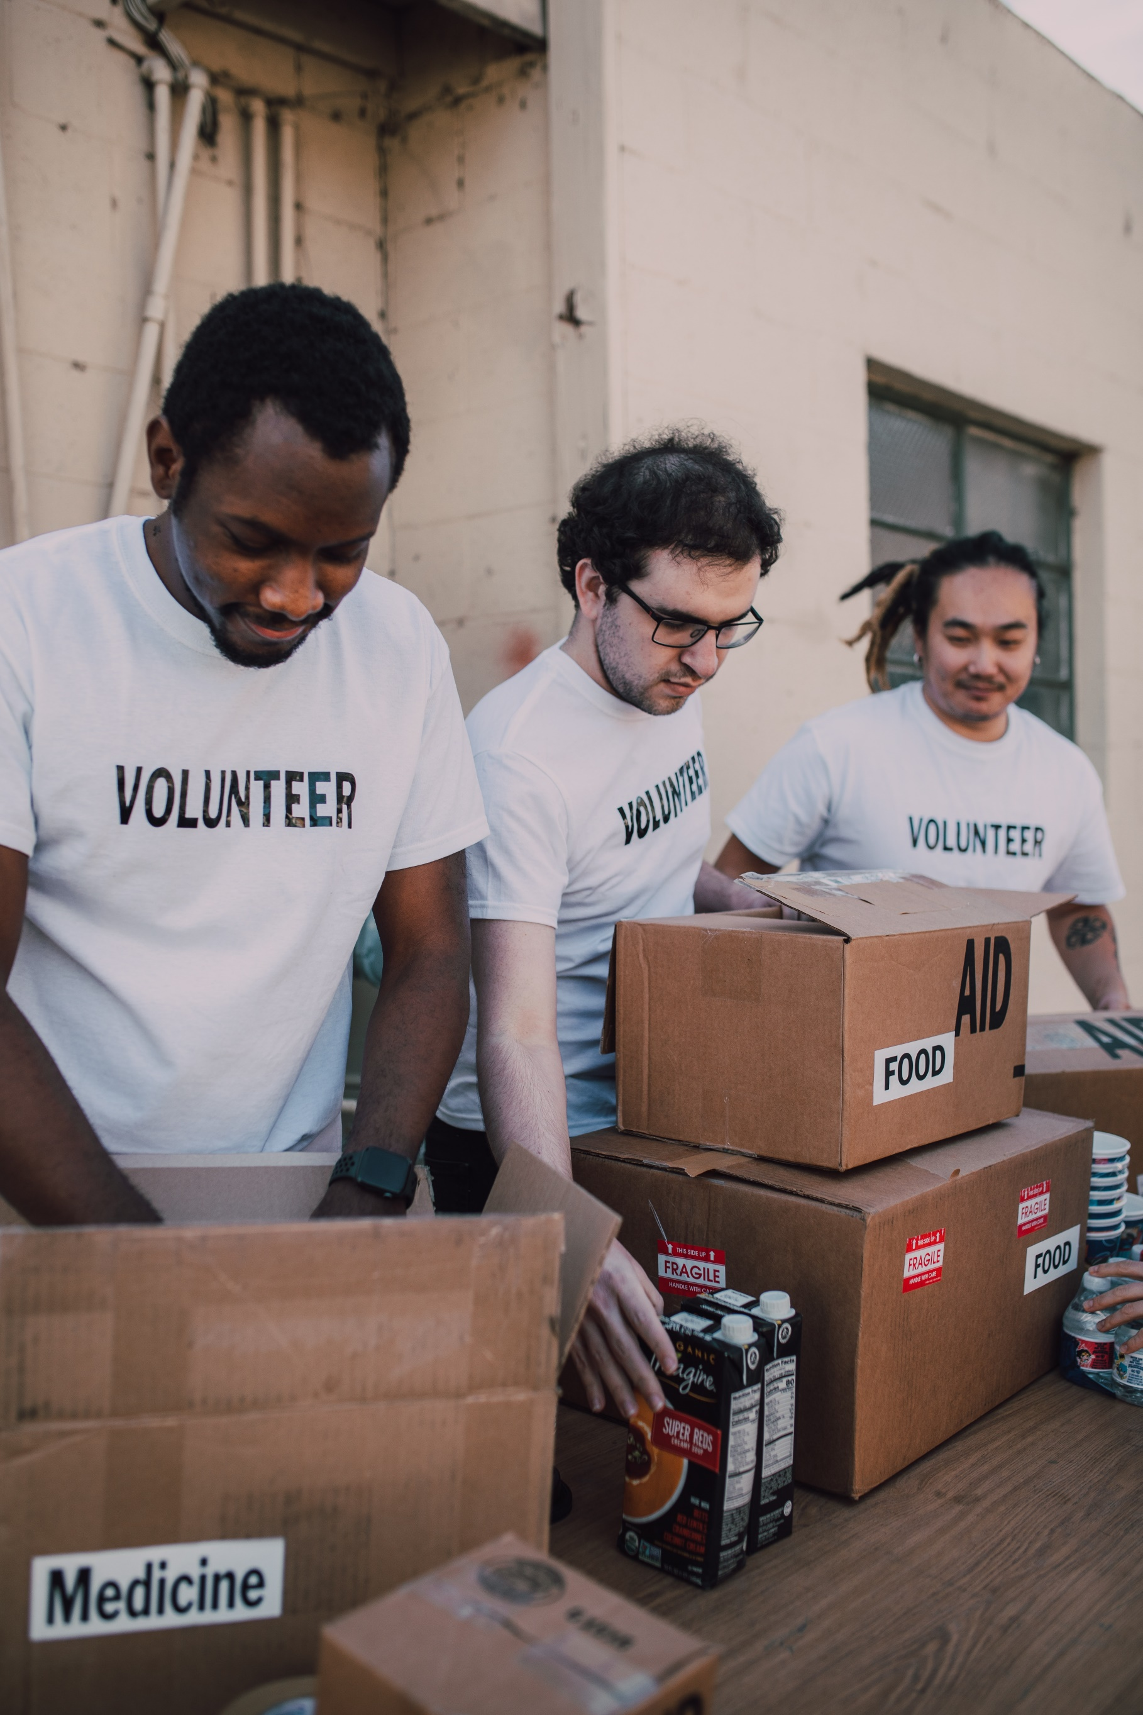CHAPTER : 01

INTRODUCTION

CONTENTS:

Name and Work of the website:

Website Requirement:

The inner links or function of the website:

In the ADMIN Module

USER Module

NAME AND WORK OF THE WEBSITE :

Give-AID (Non-Governmental Organization) website needs to be developed which will comprise of

various NGO’s. These NGO’s will take part in various welfare activities for raising funds to help the

needy. The website must flash the details of all the activities or the events which are going to

happen or conducted. It must also allow adding new NGO. The money can be paid by selecting the

desired cause. The GIVE-AID has been established with the help of many major companies

contribution.

WEBSITE REQUIREMENT :

The website is designed with the aim to help the needy. Various different types of program is being

conducted for their welfare and benefits. Following is the requirement of the website:

• The home page of the website must have these menus like “Home”, “Donate”, “Help

Centre”, “About us”, “ Our Partners”, “REGISTER”. The look of the page must be designed

with no blank space left.

• The designing section will work with two modules:

o ADMIN

o USER

• ADMIN: Admin module will manage all other content of the website like editing partner,

about us, help centre, contact us, donation link and so on.

• USER: User can see and navigate the content of the website and also can register their

account and choose the donation with concerned specified. Also they can ask others to join

by sending mail to their respective ID’s.

• Navigation of the project must be user friendly and uniform.

THE INNER LINKS OR FUNCTION OF THE WEBSITE :

In the ADMIN Module:

o Donation: In the Donation the list or other category must be included in the

application which when user wish to pay can select their concern section. For eg: a

person wants to donate for “Children Welfare Activity” or for “Disabled Person”.

o Other Partners: Various other companies associated with the organisation must be

listed with logos (can be more précised).

o About us: The link will have various sub links and for each link a page must be

designed whose information part can be edited by the admin member. Sub link such

as

▪ What we do

▪ Our mission

▪ Our team

▪ Career with us

▪ Our achievements

▪ Our supporters

▪ Read About us

o Contact Us : Contact Us page must be designed.

o Can view all the registered Member of the website.

o Donate Us Link: This link will have sub link such as:

▪ Amount

▪ Cause (which will have list like Children, Education, Disabled, Woman, Youth,

Elderly and so on)

o List of Others associated NGO’s: Admin can add the details of the NGO.

o Our Programmes: Details of the Programmes conducted by the NGO for Education,

Health Care, Privileged children (Specially challenged).

o Replying queries.

o Adding Gallery section : Images of different programmes conducted must be added by the admin

USER Module:

Users can view the page of the website but content details cannot be

edited by them. User Task includes:

o Registering their account. (need to enter few personal and professional data).

o Donate the amount (can select for which cause they want to donate) //note the

payment transaction must be maintained properly by taking card details, credit card,

debit card (though it is dummy but proper validation function must be included for it)

o Can send mail to invite other friends to join the cause

o Raise query

o Can send the interest take part in the upcoming programmes of NGO

A sample snapshot for making the donation:

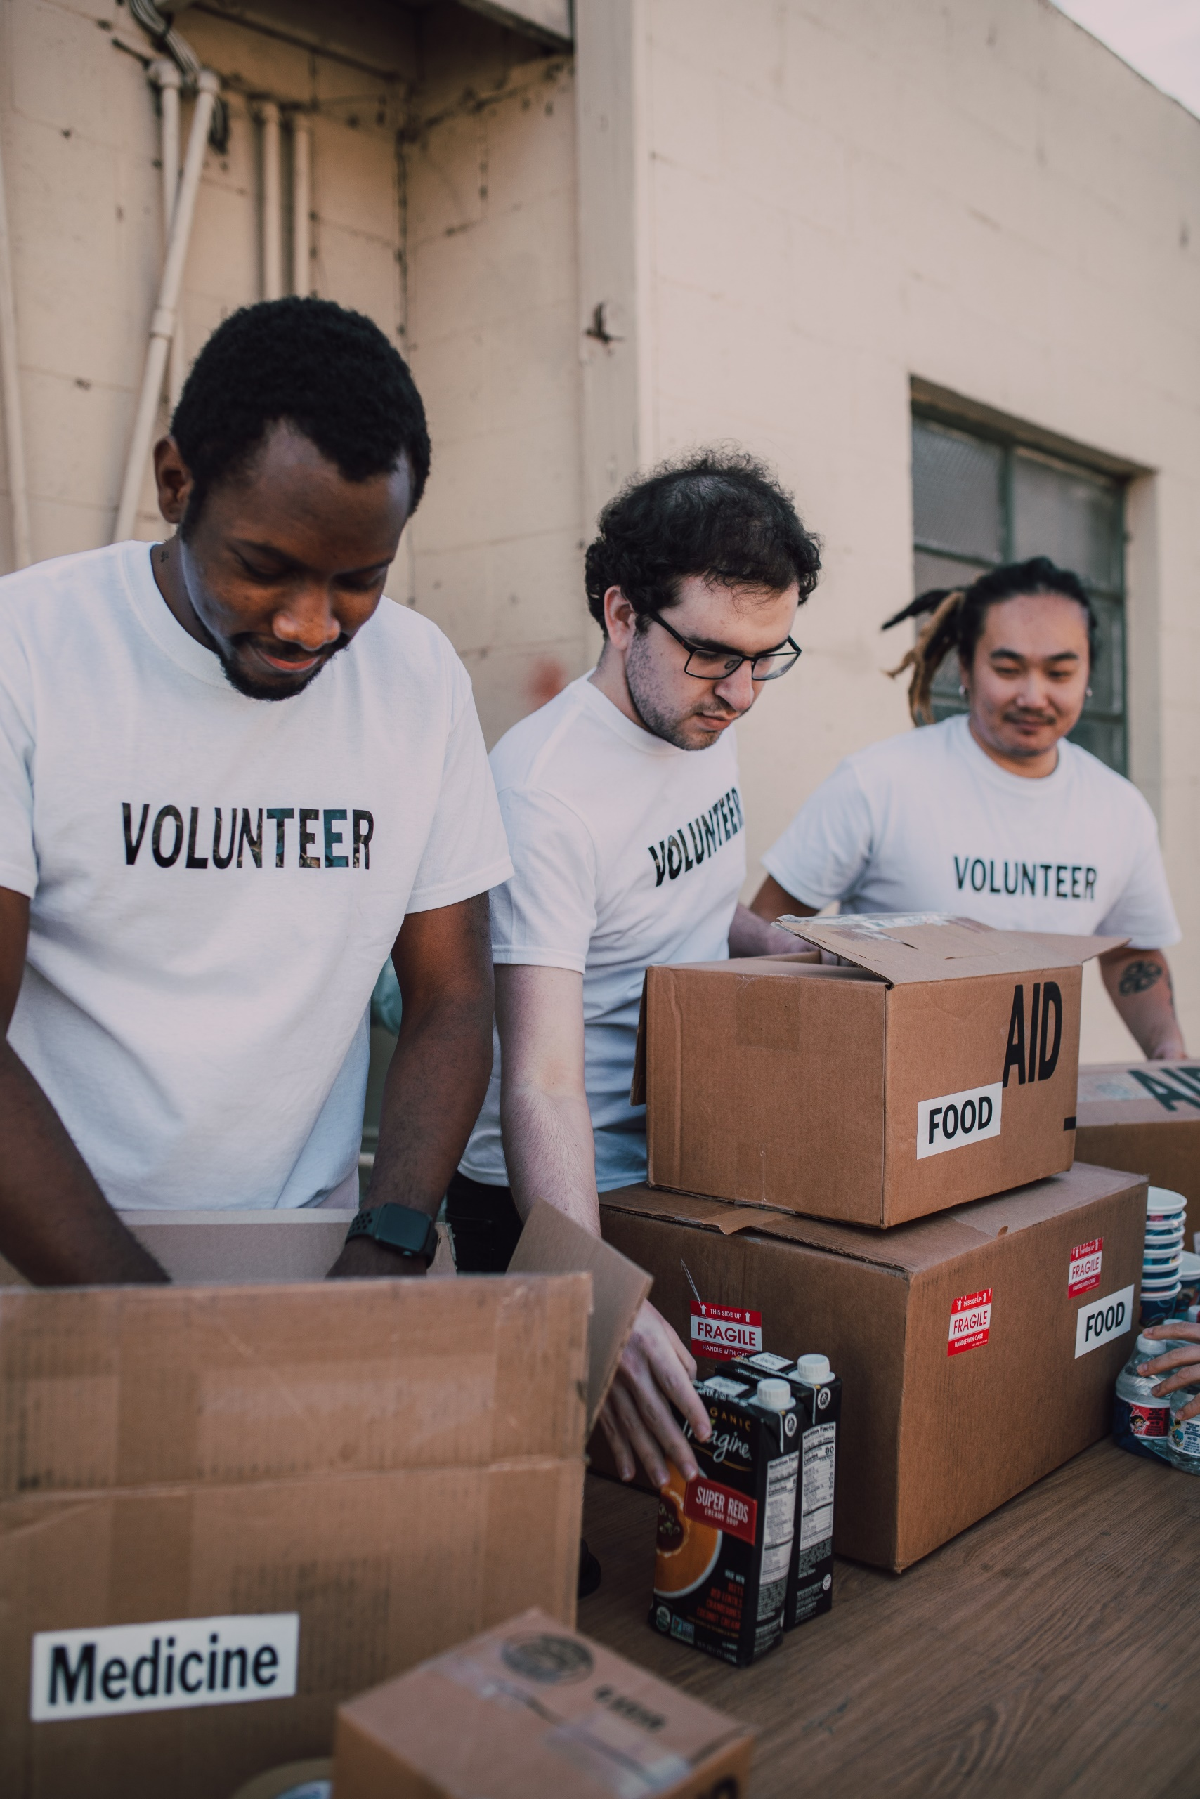 CHAPTER : 02

PROJECT MAKING & BACKGROUND

PROJECT DURATION:

* Analysis- 1 days
* Design – 10 days
* Development –15 days
* Testing – 2 days
* Documentation -2 days

|  |  |  |  |  |
| --- | --- | --- | --- | --- |
| Analysis | Design | Database | Testing | Documentation |

|  |  |  |  |  |  |  |  |  |  |  |  |  |  |  |  |  |  |  |  |  |  |  |  |  |  |  |  |  |  |
| --- | --- | --- | --- | --- | --- | --- | --- | --- | --- | --- | --- | --- | --- | --- | --- | --- | --- | --- | --- | --- | --- | --- | --- | --- | --- | --- | --- | --- | --- |
| 1 | 2 | 3 | 4 | 5 | 6 | 7 | 8 | 9 | 10 | 11 | 12 | 13 | 14 | 15 | 16 | 17 | 18 | 19 | 20 | 21 | 22 | 23 | 24 | 25 | 26 | 27 | 28 | 29 | 30 |

TASK SHEET:

|  |  |  |  |  |  |
| --- | --- | --- | --- | --- | --- |
| **No.** | **Task** | **Actual Start Date** | **Actual Days** | **Team Mate Name** | **Status** |
| 1. | Case Study | 1ST OCT  2022 | 2 | MUMAMMAD AFFAN ANSARI  , UROOJ,WANIA AAMIR | Completed |
| 2. | UI Designing | 3rd OCT 2022 | 3 | MUMAMMAD AFFAN ANSARI  , UROOJ,WANIA AAMIR | Completed |
| 3. | Scenario Making | 5th OCT 2022 | 5 | MUMAMMAD AFFAN ANSARI  , UROOJ,WANIA AAMIR | Completed |
| 4. | Material Searching | 7th OCT 2022 | 5 | MUMAMMAD AFFAN ANSARI  , UROOJ,WANIA AAMIR    HAMZA AHMAD SIDDIQUI | Completed |
| 5. | Database Connectivity | 19th OCT  2022 | 10 | MUMAMMAD AFFAN ANSARI  , UROOJ,WANIA AAMIR | Completed |
| 6. | Documentation | 29th OCT 2020 | 4 | MUMAMMAD AFFAN ANSARI  , UROOJ,WANIA AAMIR | Completed |

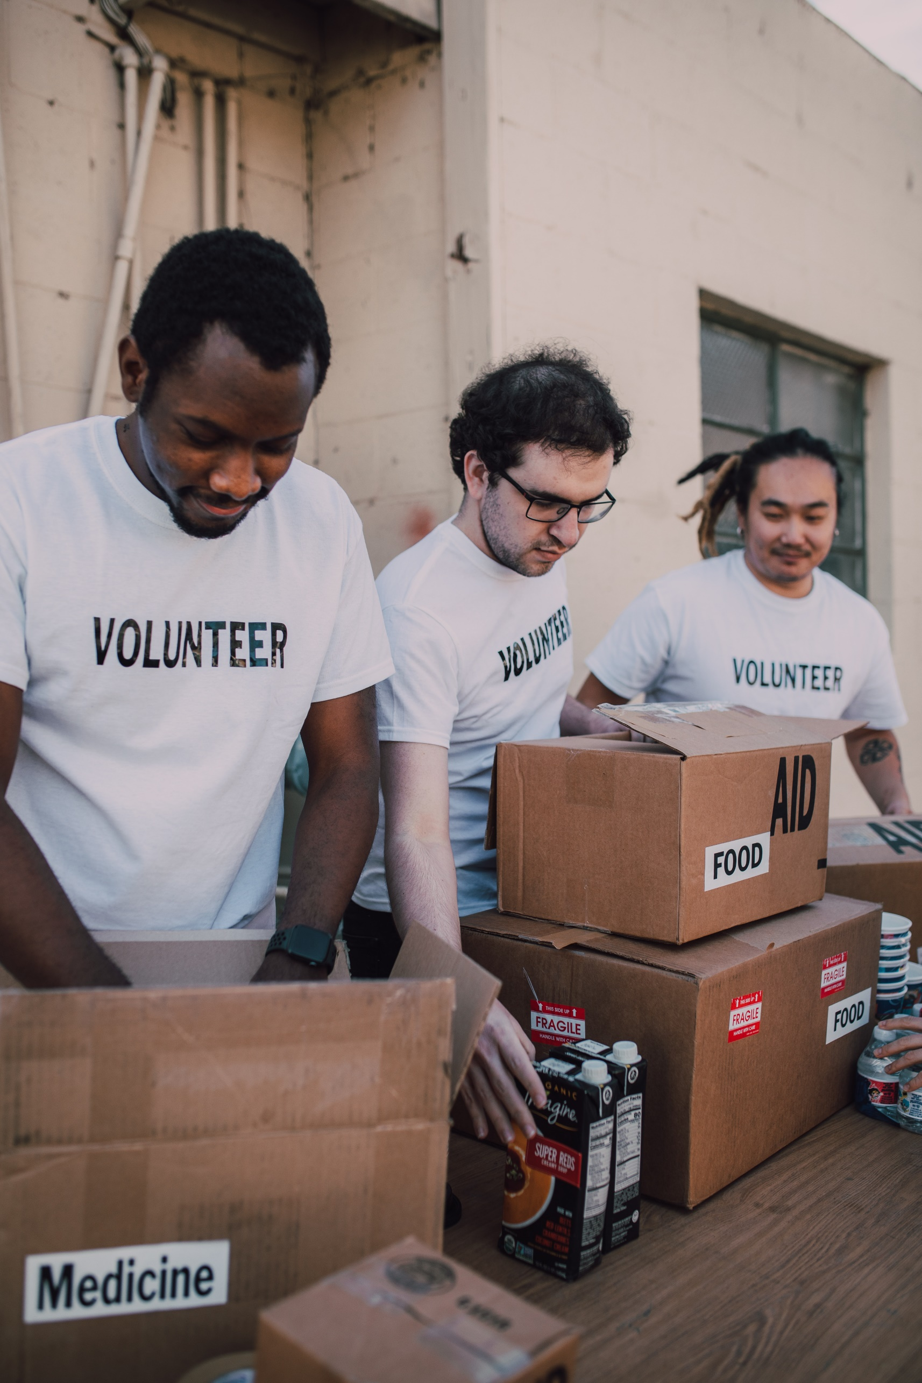 CHAPTER : 03

SOFTWARE AND HARDWARE REQUIREMENTS

HARDWARE REQUIREMENTS:

1. A minimum computer system that will help you access all the tools in the

courses is a Pentium 166 or better

2. 64 Megabytes of RAM or better

3. Windows 98 (or higher if possible)

4. Java Virtual Machine / Dot Net Framework

SOFTWARE REQUIREMENTS:

1 Notepad/HTML editor/Java editor

2 Dream weaver/JavaScript

3 j2sdk1.4.1_02 (or later) / .Net / J2EE

4 JSP / Servlets

5 EJB / Struts

6 JDBC

7 SQL Server 2000 (or later) / Oracle 9i / MS Access

8 JDBC Driver

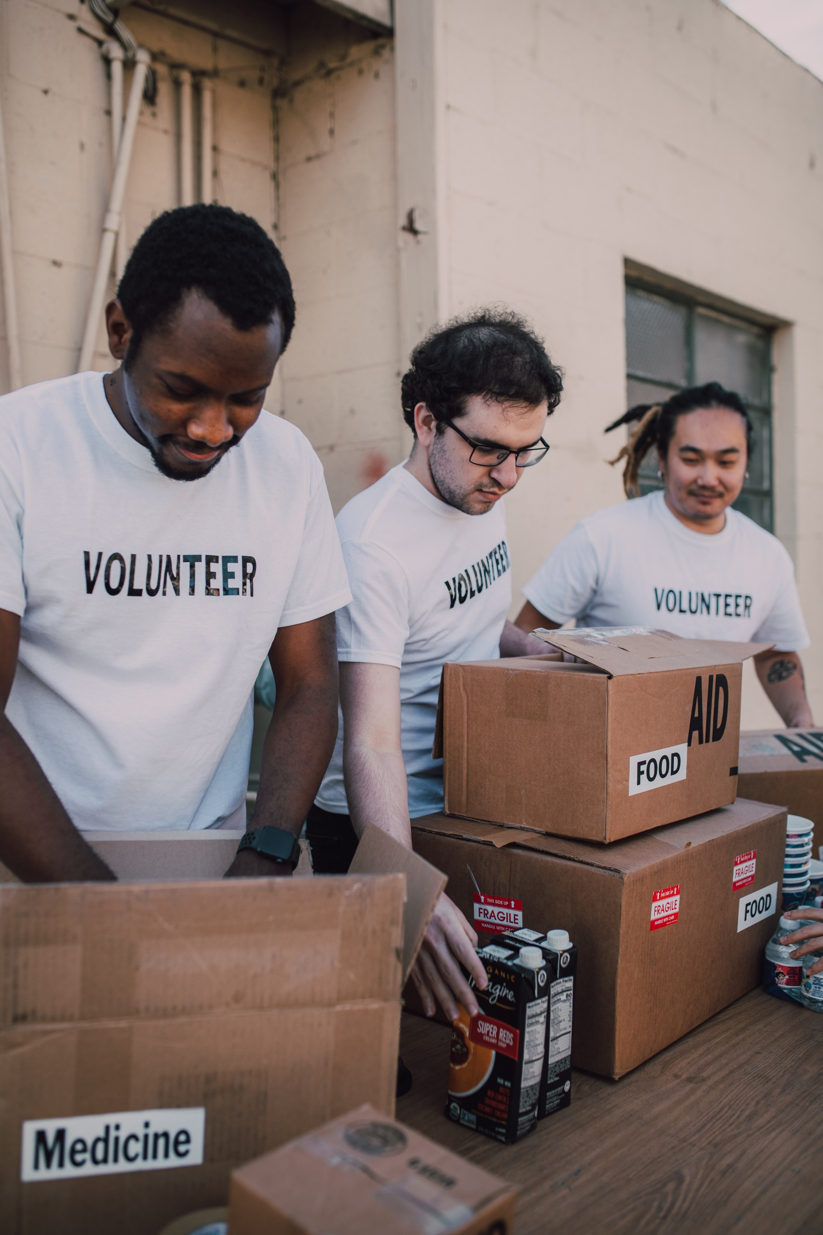

CHAPTER : 04

WORKFLOW SUBMISSION CHECKLIST

## 

WORKFLOW SUBMISSION CHECKLIST:

|  |  |  |  |
| --- | --- | --- | --- |
| **S.NO** | **LIST OF ITEMS** | **Remarks** | **COMMENTS** |
| 1. | Do All Pages  Linked together | **Yes** | Through the URL.. |
| 2. | Database Connected | **Yes** | Using  MDF FILE |
| 3. | Page Colors As Per Common Guidelines | **Yes** | Professional Color Combination |
| 4. | All Tables  Working | **Yes** | No Comments |
| 5. | DOCUMENTATION Included | **Yes** | All 3 word documents. |
| 6. | Project Zip File | **Yes** | Created using WinRAR |



CHAPTER : 05

SCREENSHOTS

SCREENSHOTS:

This is the Home Page.

# 

This is the Footer of our web.

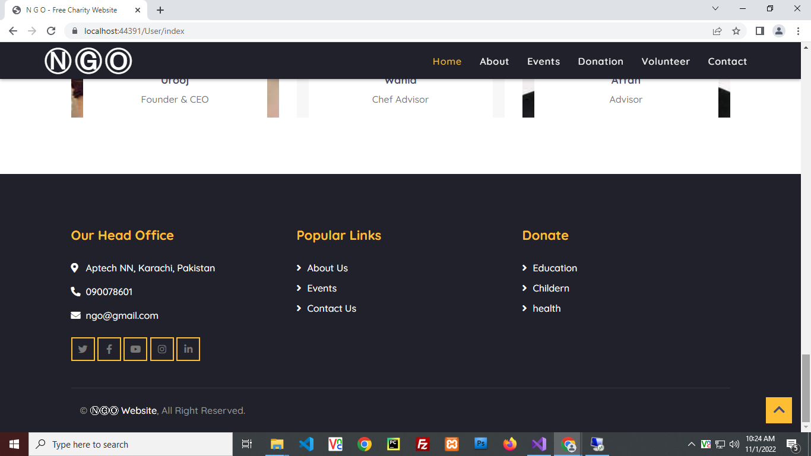

This is the about us page.

# 

This is the Contact us Page.

# 

This is where you Register yourself as a volunteer.

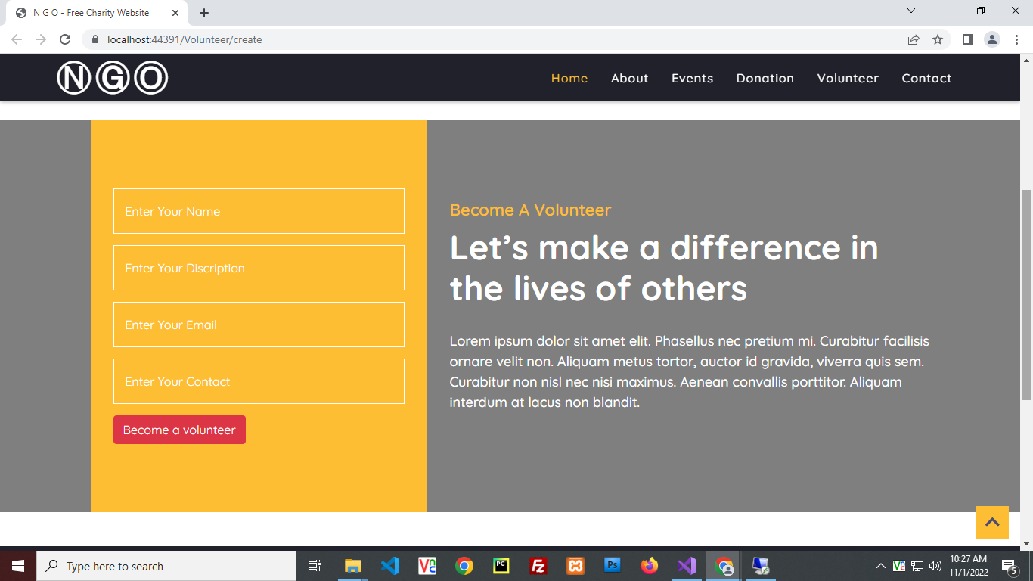

After Signup you will go to Userlogin

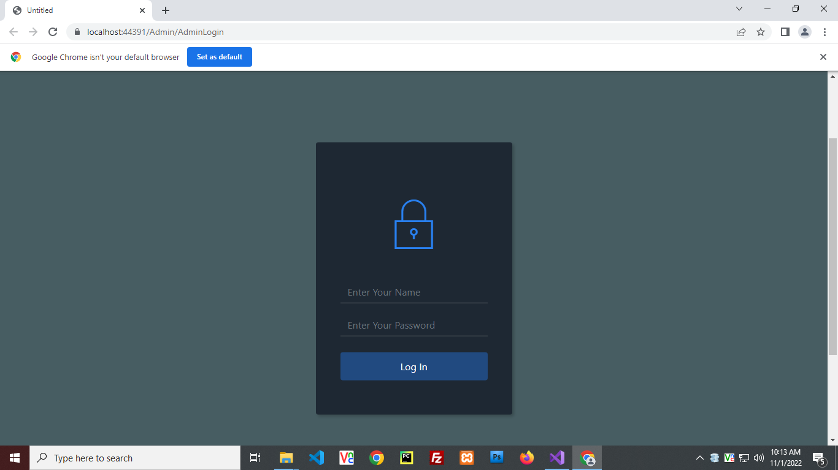

Our upcoming events.

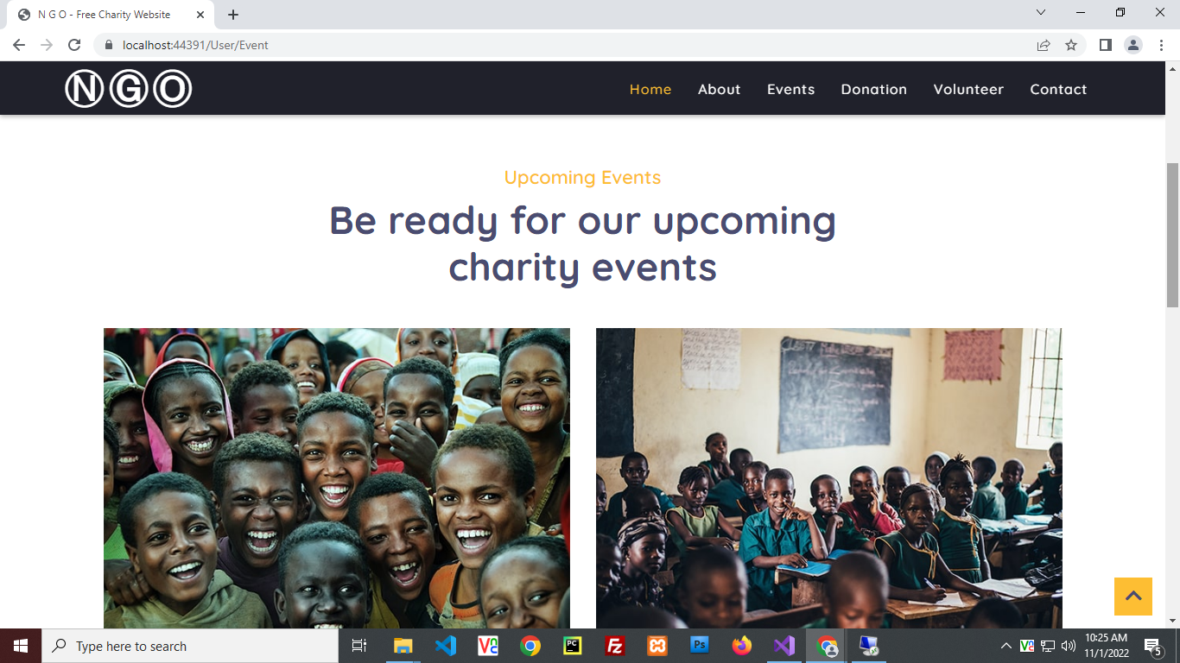

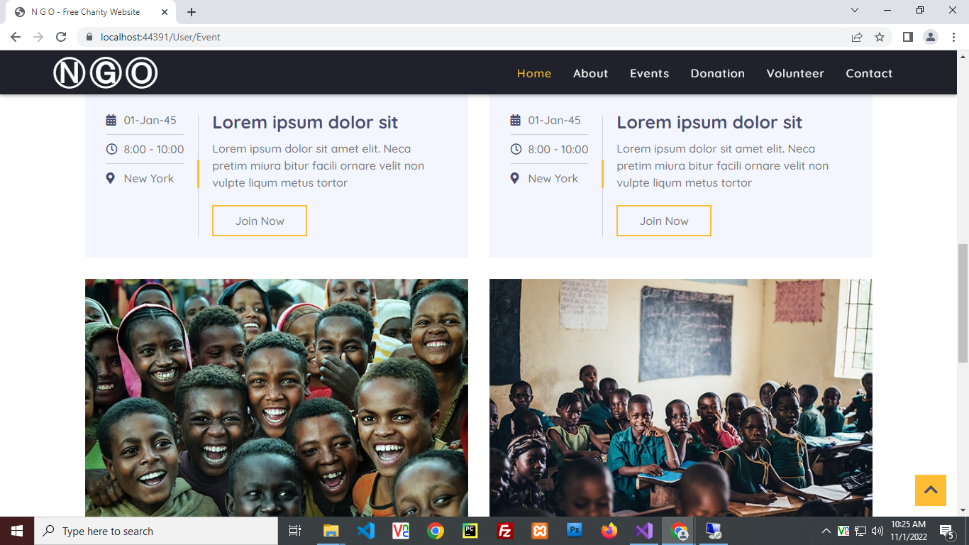

This Is Admin View

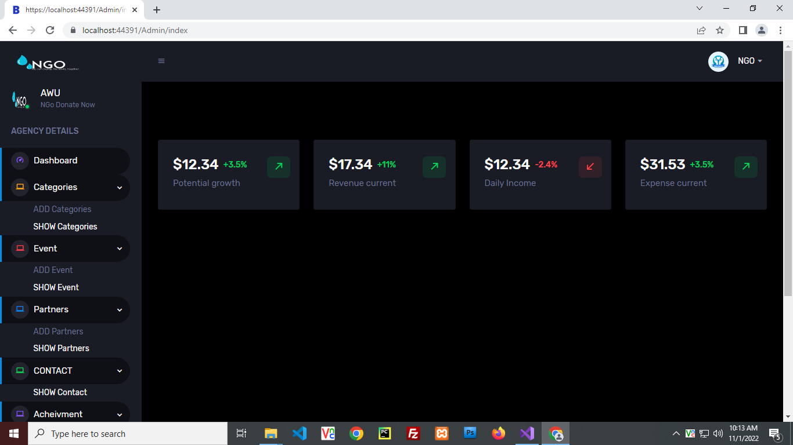

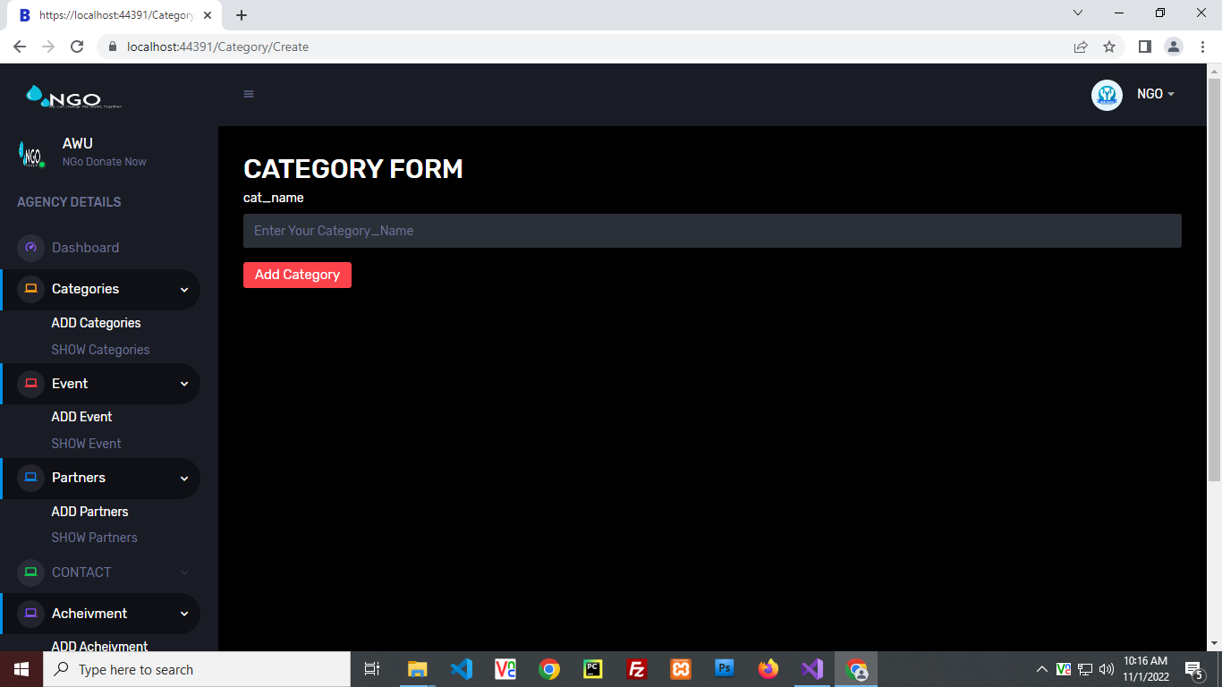

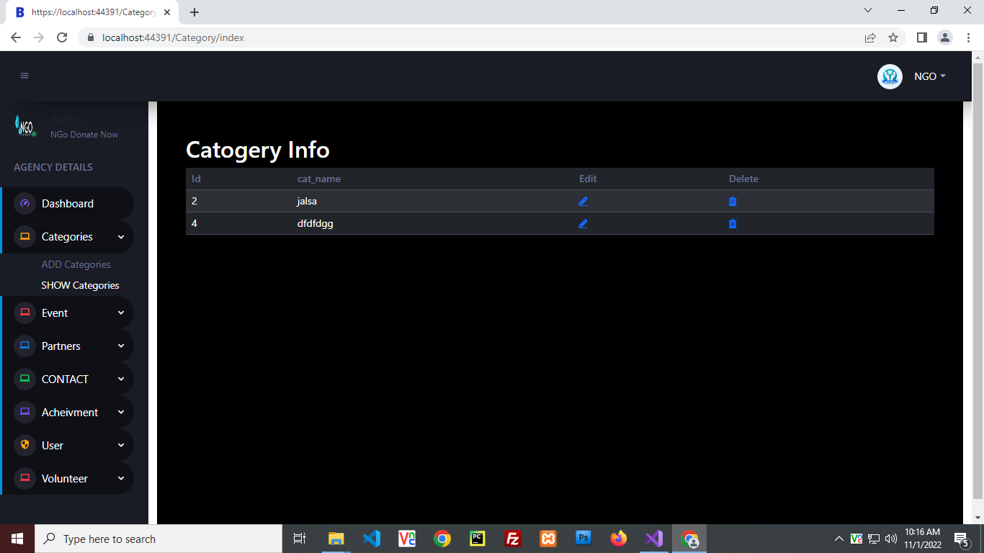

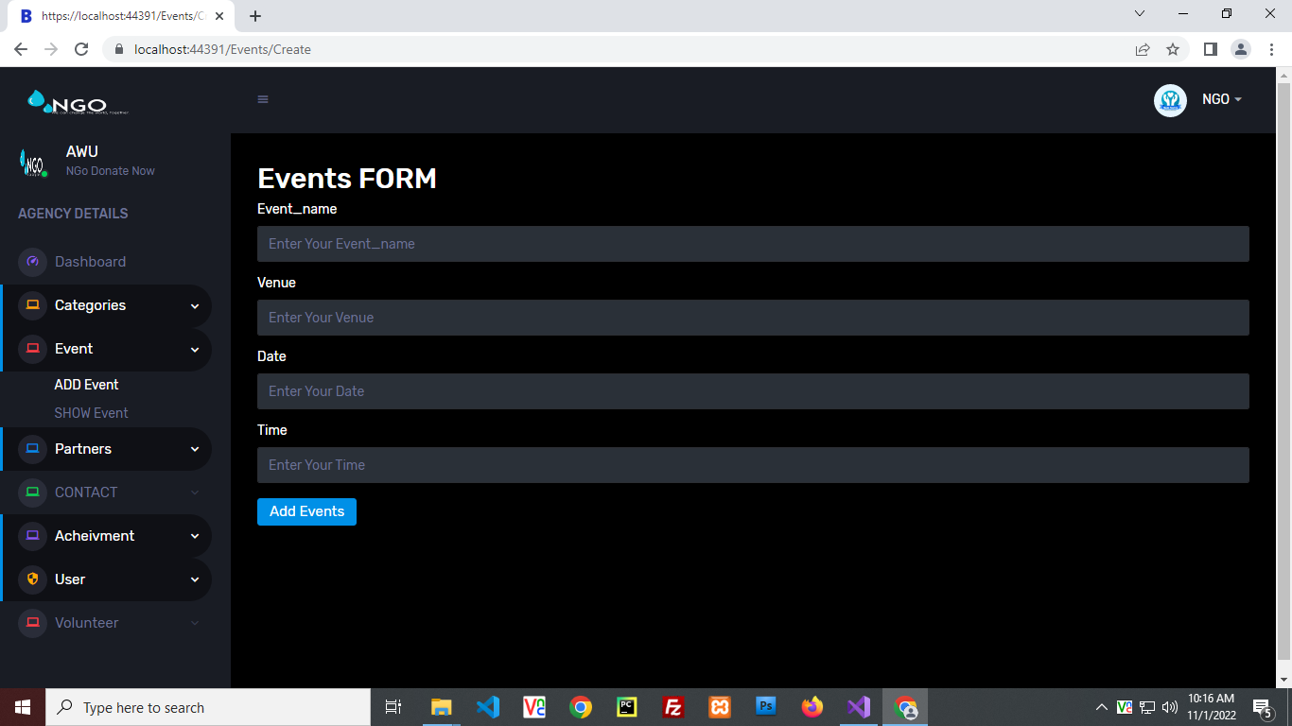

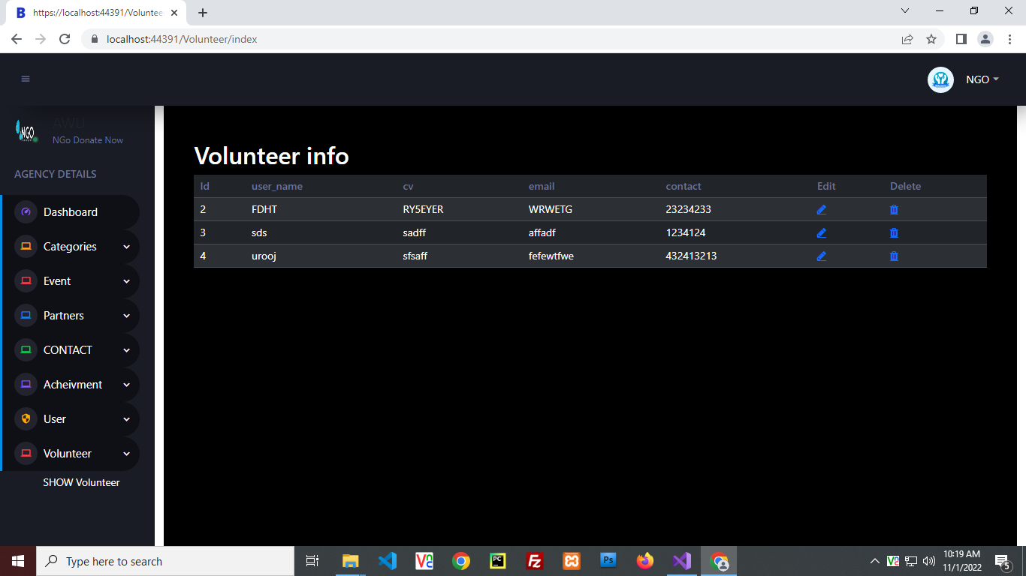

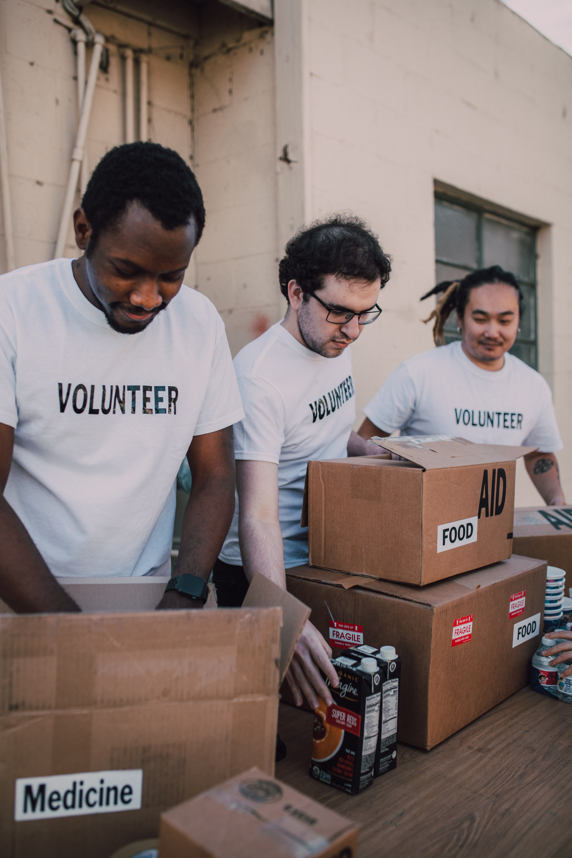 CHAPTER : 06

CONCLUSION

Remarks:

It is very nice initiative that has made us work harder on our project and it has polished our skills now I am capable of making a Website by own self. I am very thankful to you.

Problem Faced:

Version issues of visual studio haunted us a big time overall it was a great experience.

Future Enhancement:

It is almost a perfect prototype of Airlines Reservation system. This Websites can be deployed and used in real world! But there is always a place for betterment so ere are our few suggestions, Enclosures will be added soon. Also interaction with our regular customers can be maintained using mail, message etc.